NYC MapPLUTO dataset
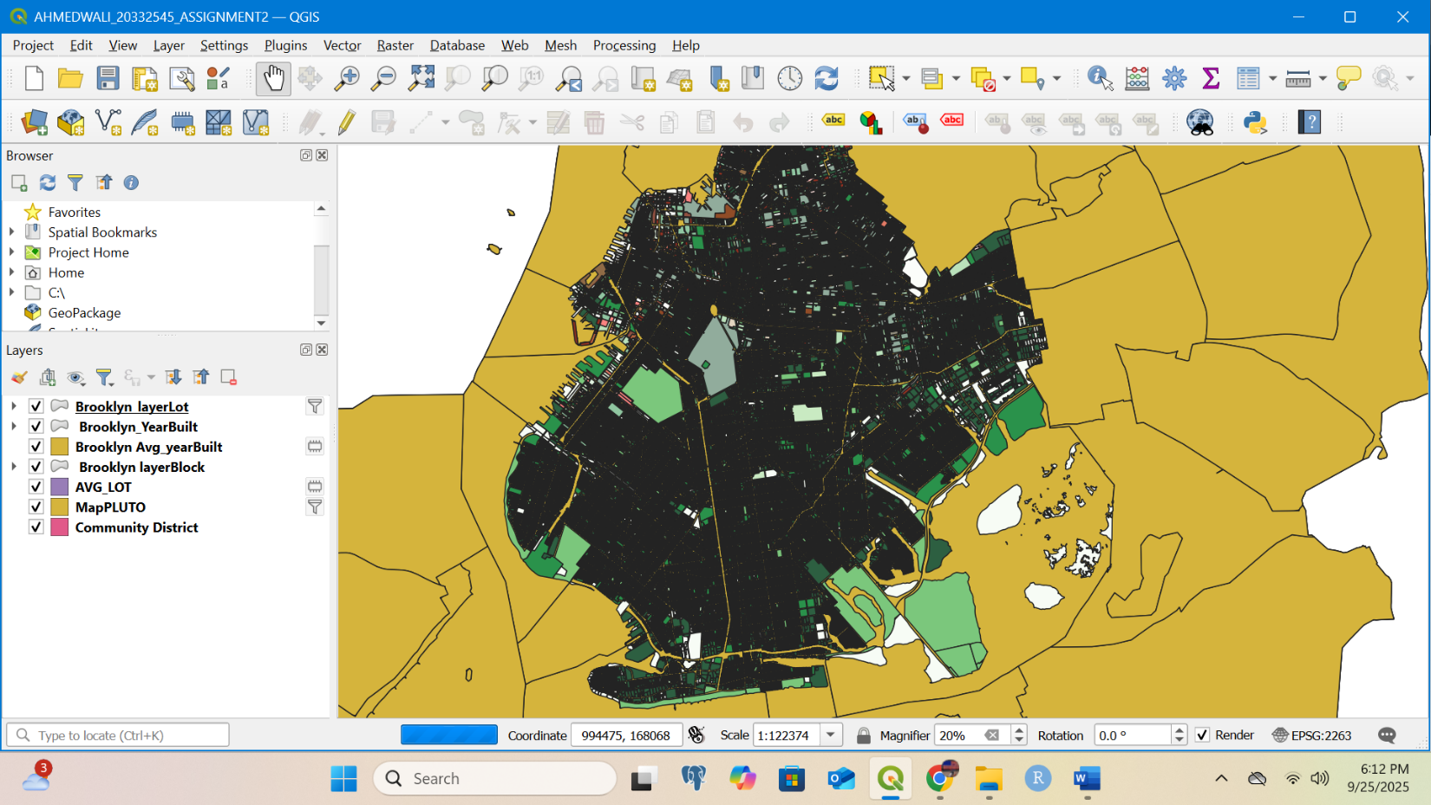In this project, I worked with the NYC MapPLUTO dataset, borough boundaries, and community district polygons. I set the project CRS to NAD83 / New York Long Island (ftUS) (EPSG:2263) to ensure distances and areas were represented correctly.
First, I filtered the MapPLUTO dataset to include only Brooklyn tax lots ("Borough" = 'BK'). From this selection, I created new layers such as Brooklyn_layerLot, Brooklyn_YearBuilt, and Avg_lot to summarize the data by borough. For example, I calculated average building year built and average lot size for Brooklyn parcels.
Next, I incorporated the Community District shapefile to perform spatial analysis. Using Join Attributes by Location (Summary), I connected Brooklyn tax lots with their corresponding community districts. This allowed me to calculate and map summary statistics, such as the number of lots or the average year built per district.
For visualization, I applied choropleth symbology to display variation in building age and lot size across Brooklyn. This symbology highlights patterns of older versus newer development, as well as differences in lot sizes between neighborhoods.
Through these operations, the final map provides both a spatial and statistical perspective on Brooklyn’s built environment, connecting parcel-level data from MapPLUTO with community-level patterns.

